FM Transmitter
Chris Barr Jett Guerrero

Goal
To create a small device that will be capable of transmitting an audio wave to an FM frequency (88MHz – 108 MHz). Also, to be able to change the broadcasting frequency of the device. We will become our own radio station with a very small radius. The FM transmitter will be capable of operating with smartphones or mp3 players to broadcast music to a radio.

Introduction
A small FM Transmitter used to be more common years ago. These transmitters would be used in cars to play the users mp3 player onto their own RF channel (Radio Frequency). The way it works is that the input signal and the carrier wave signal are modulated through frequency modulation. The audio is then broadcasted to a standard FM radio. Over time technology improved to a better transmitter, this is known now as Bluetooth.
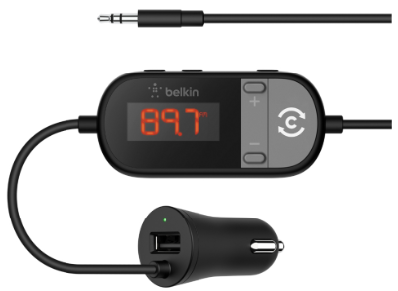
Fig. 1: Consumer example of an FM Transmitter

Theory
Radio frequency can be described as a carrier signal wave which resembles a sine wave. The carrier wave is a wave with no information or speech within the wave. In an FM transmitter, the input signal is imposed onto the carrier wave and this process is called modulation. With the new modulated wave, the carrier wave has been transformed and modified to carry the information or speech from the input signal. The NPN 2N3904 transistor is used as the circuits oscillator to obtain the carrier wave frequency. The input audio signal modulates the LC circuit carrier frequency in FM format through the base of the transistor.
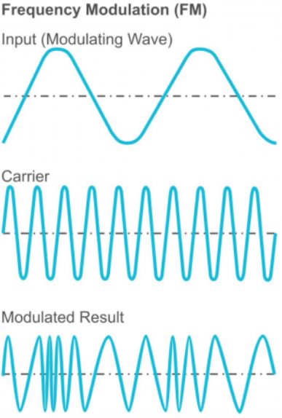
Fig. 2: Carrier affecting the audio
United States allows 88MHz to 108MHz as commercial, or consumer use. The bandwidth is about 180 KHz (roughly 0.2MHz). This means a user of a standard FM radio can choose a station going between 88MHz to 108MHz every 0.2MHz. That’s about 100 stations worth of radio transmissions.

Implementation
To create a small frequency transmitter, the circuit did not require a large number of components. Check the bottom of the report for the ‘Bill of Materials’ to see the list of components used in this project.
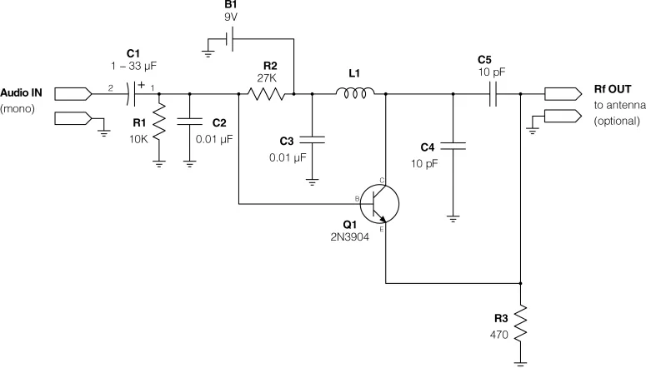
Fig. 3: Circuit Design for the FM Transmitter
As seen in Fig. 3, Audio IN is the mono audio input that is coupled by the 33uF coupling capacitor to let in only AC signals to go through to the base of the transmitter. R1 and C2 are used to filter by decoupling. The transistor oscillates to create the resonance in the collector node also known as the carrier wave. L1 is the handmade inductor that can help tune the frequency, alongside C4. The emitter node then allows this oscillated value to output through Rf OUT, allowing the audio input to broadcast through an RF signal.
The project was implemented by using the Manhattan Style technique, also known as Dead Bug to avoid parasitic capacitance, inductance and resistance from the rails and rows of a breadboard. The circuit is placed on a thin layer of copper, with fiber glass on the other side; a copper clad board. A small piece of the copper clad board is cut out and placed on top of the main board which is then layered with solder to act as the battery pad for the 9V battery source to separate the connection from the ground plane. The components are then soldered onto the board using the copper as a floating ground.
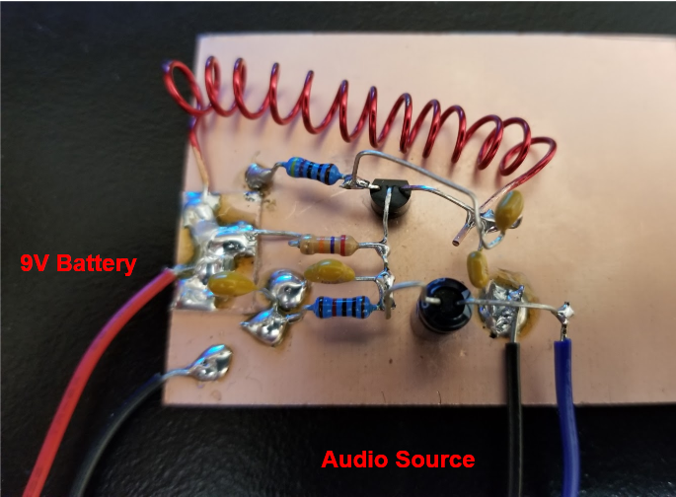
Fig. 4: Dead Bugged Board of FM Transmitter
To find the radio frequency the FM Transmitter was transmitting, the use of the Spectral Analyzer made quick pace of finding the exact value. The Spectral Analyzer uses a Frequency (x) vs. Amplitude (y) graph to determine the exact FM a standard radio needed to find projects transmission.

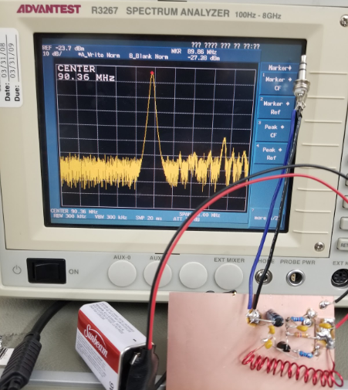
Fig. 5: Spectrum Analyzer
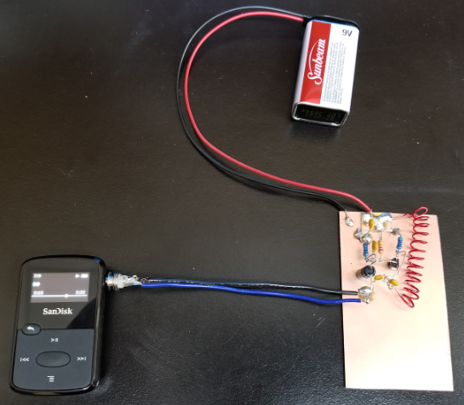
Fig. 6: Full setup for FM Transmitter
In Fig. 5 a marker is used to determine the frequency wave the inductor is inducing to be at roughly 90.4 MHz. The project can now broadcast on FM 90.4. To change the frequency of the FM transmitter, capacitor C4 needs to be changed to a different capacitance value or change it to a variable capacitor. For this project, the inductor coil was used to change and tune the frequency. Increasing the length of the inductor increases the frequency and vice versa. With only four loops in the coil, the frequency the circuit was oscillating at was 180MHz. After adding another loop with a total of five loops, the frequency dropped to 150MHz which is still out of range for the FM band. In the final inductor coil, thirteen loops were made and the frequency dropped to around 85MHz which is too low. To increase the frequency, the inductor coil was lengthened until the desired frequency value was reached using the Spectrum Analyzer. Currently, the FM transmitter does not have an antenna and can transmit audio signals with approximately a 15-foot radius. Adding an antenna will increase the transmission range.
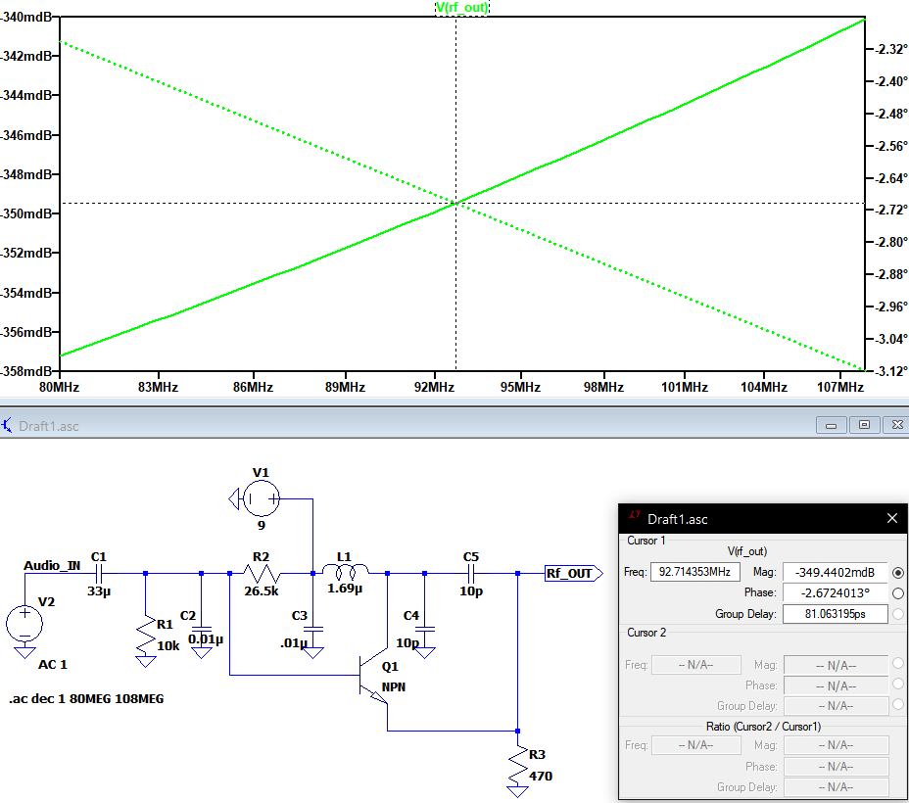
The LTspice simulation shows that the circuit will have a frequency of about 92MHZ-93MHz which is very close to the actual frequency produced by the transmitter.
Bill of Materials
- 2N3904 NPN Transistor
- 9v battery
- Mono or stereo 3.5mm plug
- 20 gauge solid copper wire
- 2x .01uF ceramic capacitor
- 2x 10pF ceramic capacitor
- 33uF electrolytic capacitor
- 9v battery and battery clip
- 470 ohms, 10k ohms, 27k ohms
- Copper-clad board

