University of Nevada Las Vegas. Department of Electrical and Computer Engineering Laboratories.
Class: | EE221 Circuits II |  |  | Semester: | Spring 2018
Points |  | Document author: | Christopher Barr, Jett Guerrero, Ivan Soto
 |  | Author's email: | barrc1@unlv.nevada.edu, guerrj1@unlv.nevada.edu,  sotoi2@unlv.nevada.edu
 |  | Document topic: | Final Report
Instructor's comments:

The Goal:

The goal of this project is to create a Battery Voltage Monitor on the breadboard. This battery voltage monitor is designed to inform the user if they are overcharging or supplying low voltage to their battery. In this circuit, when the supplied voltage is 13.5V, then the red LED diode will turn on and when the voltage is under 10.5V, the green LED diode will be turned on.

Group Roles:

Christopher Barr: Responsible for building the circuit according to the schematic used.
Jett Guerrero, Ivan Soto: Responsible for debugging the circuit after it was built and fixing any errors.

Operation: The diodes in our circuit will only let the current in our circuit move in one direction easier than the other direction.The potentiometer is a part in our circuit that creates a variable resistance on either end. It takes divided voltage from the two resistors and provides a pin to use the voltage.
Background Theory:

The parts of the schematic serves many different functions that are important to the operation of the circuit as a whole. Diode D1 is used to pull any leftover current out of the op amp. The Potentiometer in our circuit will supply the op amp’s negative terminal with the divided voltage based on the variable resistors’ values. It provides a resistance of up to 10k ohms. The op amp is used to amplify low voltages to higher voltages, and invert them as well.

Schematics, Diagrams, etc:

Circuit Schematic:

Circuit 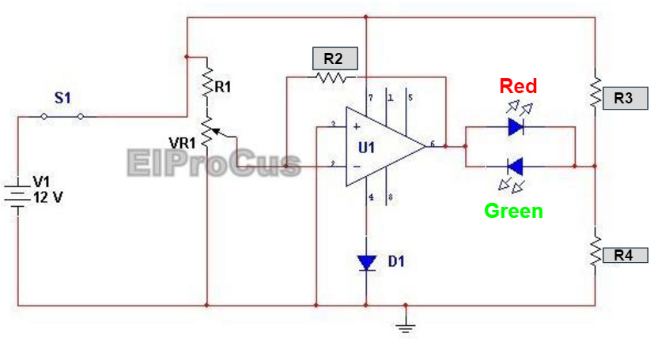

Implementation:
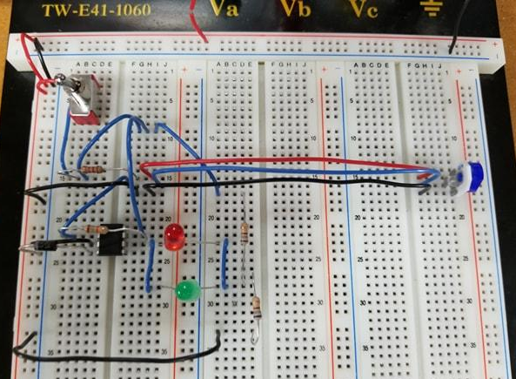
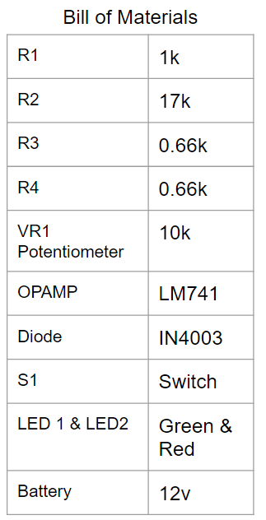

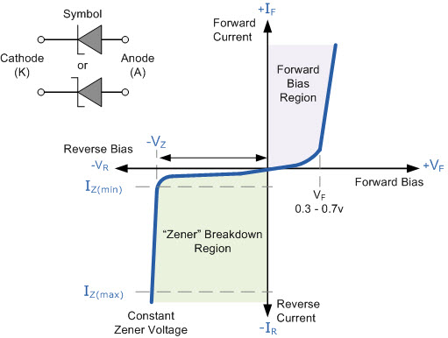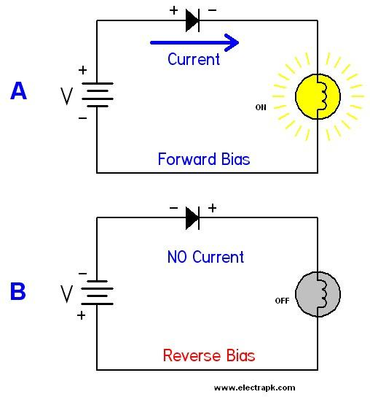
Breakdown with LEDs as one is off, the other is on.

Circuit Operation:
- “When the voltage level of the battery falls to 10volts, the voltage at the inverting terminal is less than the voltage at the non inverting terminal. The OPAMP output goes high. LED2 begins to emit GREEN light which indicates that the battery needs to be charged.”
- “Similarly, when the voltage fall below a preset level (10Volts) the output goes high and the LED start to emit GREEN light.”
- Diode needed to be connected to the OpAmp to prevent over voltage.

Conclusions:

The circuit that was built for this project taught us how to use the many different components in our circuit. We were given a look into using diodes, which are a fairly new component for us. By building this circuit, we learned about potentiometers, a component that we have never used before. And we got to learn more about the behavior of the LM 741 op amp. The project as a whole helped us work together as a team to complete a project within a specified amount of time. It was a valuable learning experience that helped us develop our problem solving skills.

